1: Student Academic Performance Dashboard
attendance <- c(90, 80, 70, 85, 95)
marks <- c(88, 75, 65, 80, 95)

plot(attendance, marks,
main = "Student Academic Performance Dashboard",
xlab = "Attendance (%)",
ylab = "Internal Marks",
pch = 19,
col = c("red", "blue", "green", "orange", "red"))
legend("topleft",
legend = c("CSE", "AI", "IT", "ECE"),
col = c("red", "blue", "green", "orange"),
pch = 19)

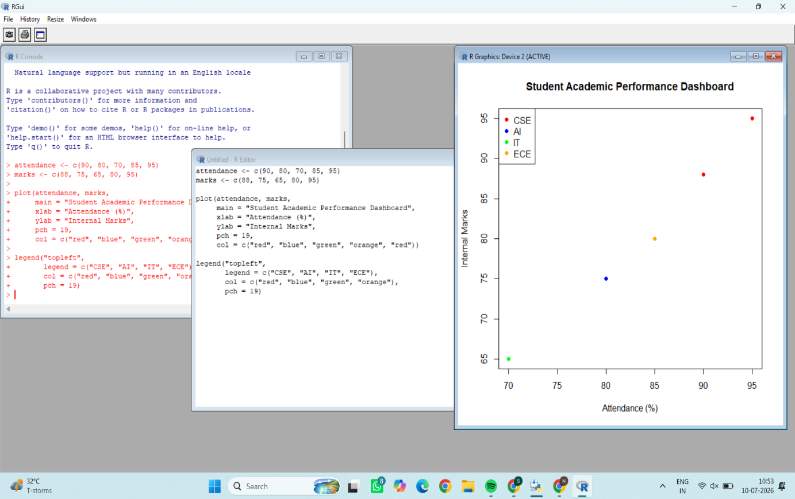

2: Electric Vehicle Market Analysis

battery <- c(30, 40, 50, 60, 75)
price <- c(10, 15, 20, 25, 35)
range <- c(200, 250, 300, 350, 450)

plot(battery, price,
main = "Electric Vehicle Market Analysis",
xlab = "Battery Capacity (kWh)",
ylab = "Price",
pch = 19,
cex = range / 100,
col = c("red", "blue", "green", "orange", "purple"))

legend("topleft",
legend = c("Tata", "MG", "Hyundai", "Mahindra", "Tesla"),
col = c("red", "blue", "green", "orange", "purple"),
pch = 19)
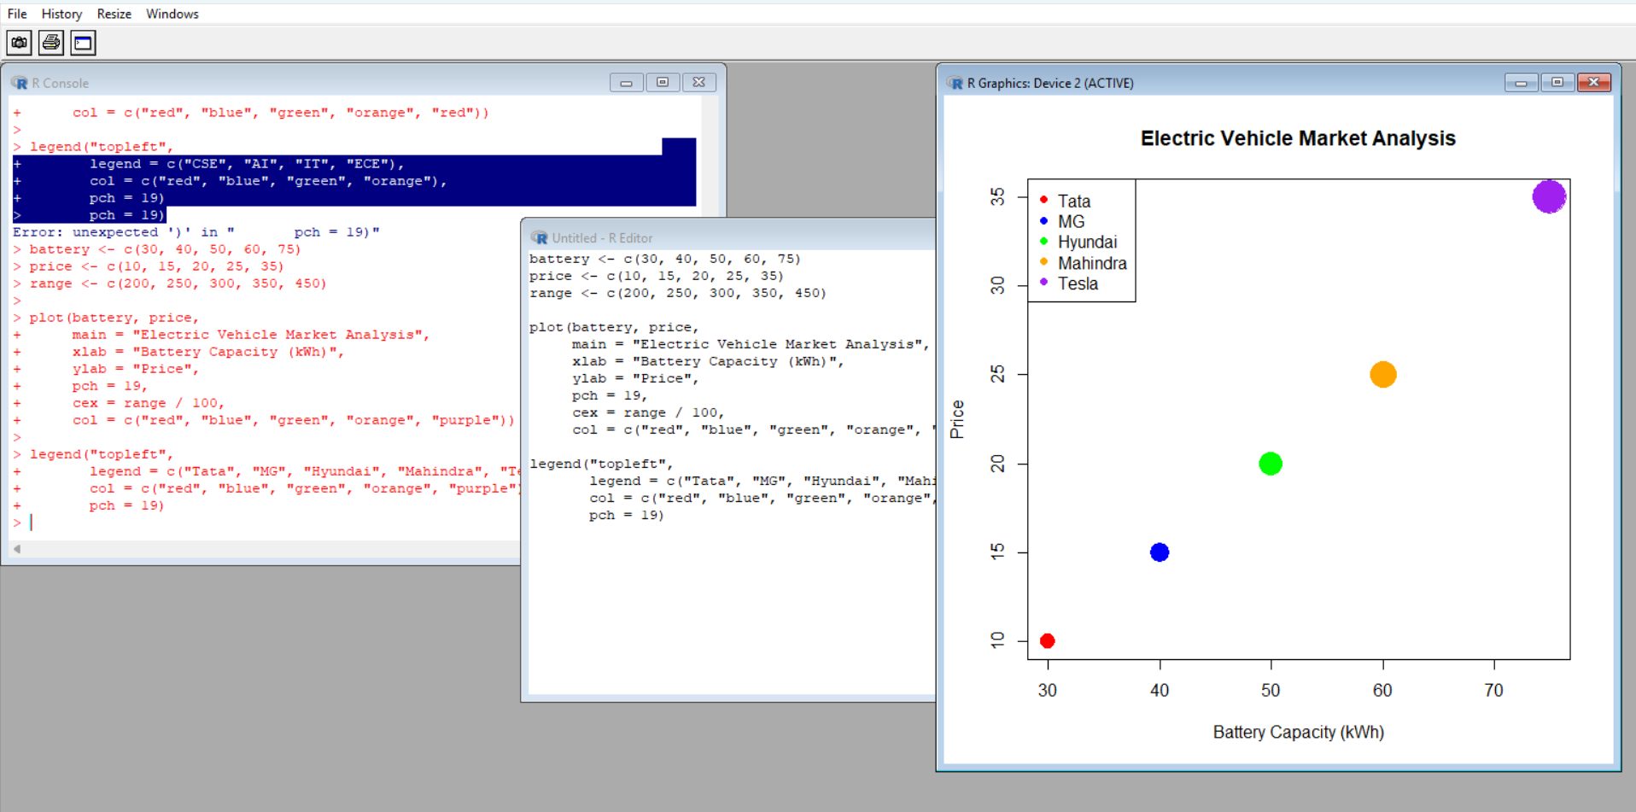

3: Hospital Patient Admission Analysis

department <- c("Cardiology", "Neurology", "Orthopedics", "Pediatrics")
patients <- c(120, 90, 150, 100)
cost <- c(5000, 7000, 6000, 4000)

bar <- barplot(patients,
names.arg = department,
col = c("red", "blue", "green", "orange"),
ylim = c(0, 170),
main = "Hospital Patient Admission Analysis",
xlab = "Department",
ylab = "Number of Patients")

text(bar, patients + 5, labels = cost)

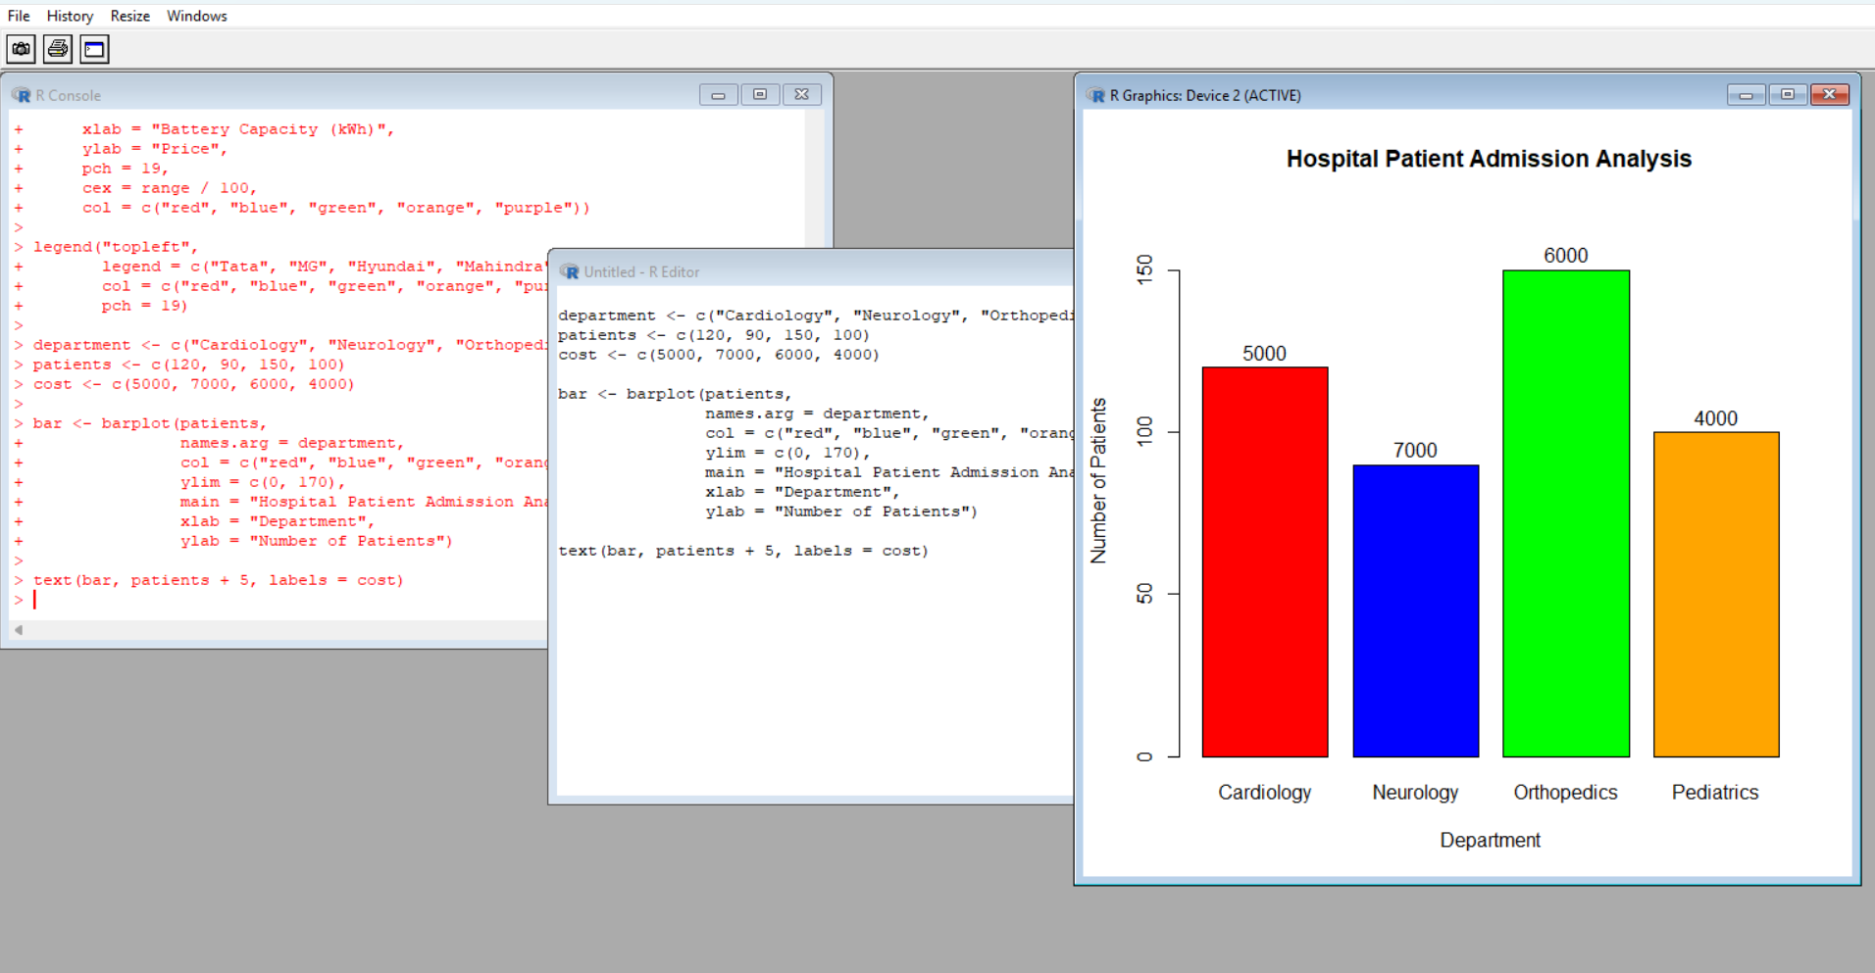

4: Weather Monitoring System
date <- 1:5
chennai <- c(32, 33, 34, 33, 35)
delhi <- c(36, 37, 38, 37, 39)
mumbai <- c(30, 31, 31, 32, 33)

plot(date, chennai, type = "l",
col = "red", lty = 1, lwd = 2,
ylim = c(30, 40),
xlab = "Date",
ylab = "Temperature (°C)",
main = "Weather Monitoring System")
lines(date, delhi, col = "blue", lty = 2, lwd = 2)
lines(date, mumbai, col = "green", lty = 3, lwd = 2)
legend("topleft",
legend = c("Chennai", "Delhi", "Mumbai"),
col = c("red", "blue", "green"),
lty = c(1, 2, 3),
lwd = 2)
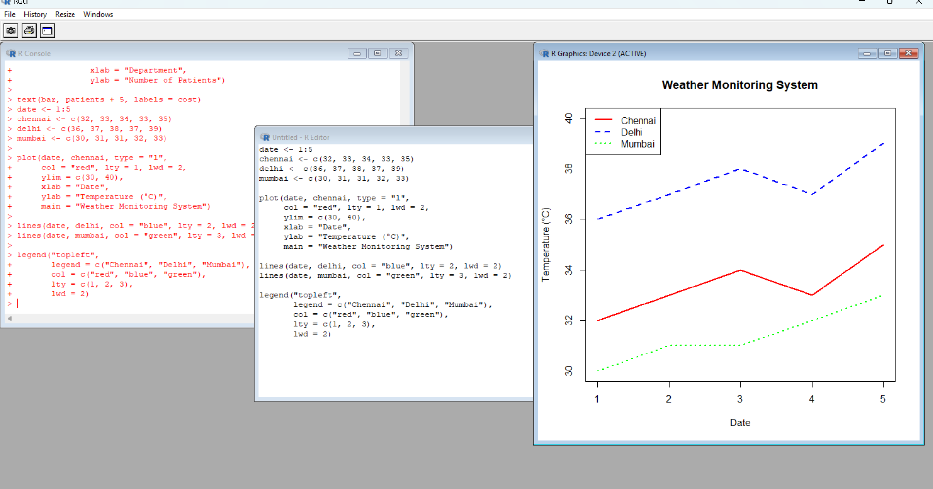
5: Supermarket Sales Analysis

sales <- matrix(c(500,700,
600,650),
nrow=2)

barplot(sales,
beside=TRUE,
col=c("red","blue"),
names.arg=c("Food","Drinks"),
main="Supermarket Sales Analysis",
xlab="Product Category",
ylab="Sales Amount")

legend("topright",
c("Branch A","Branch B"),
fill=c("red","blue"))
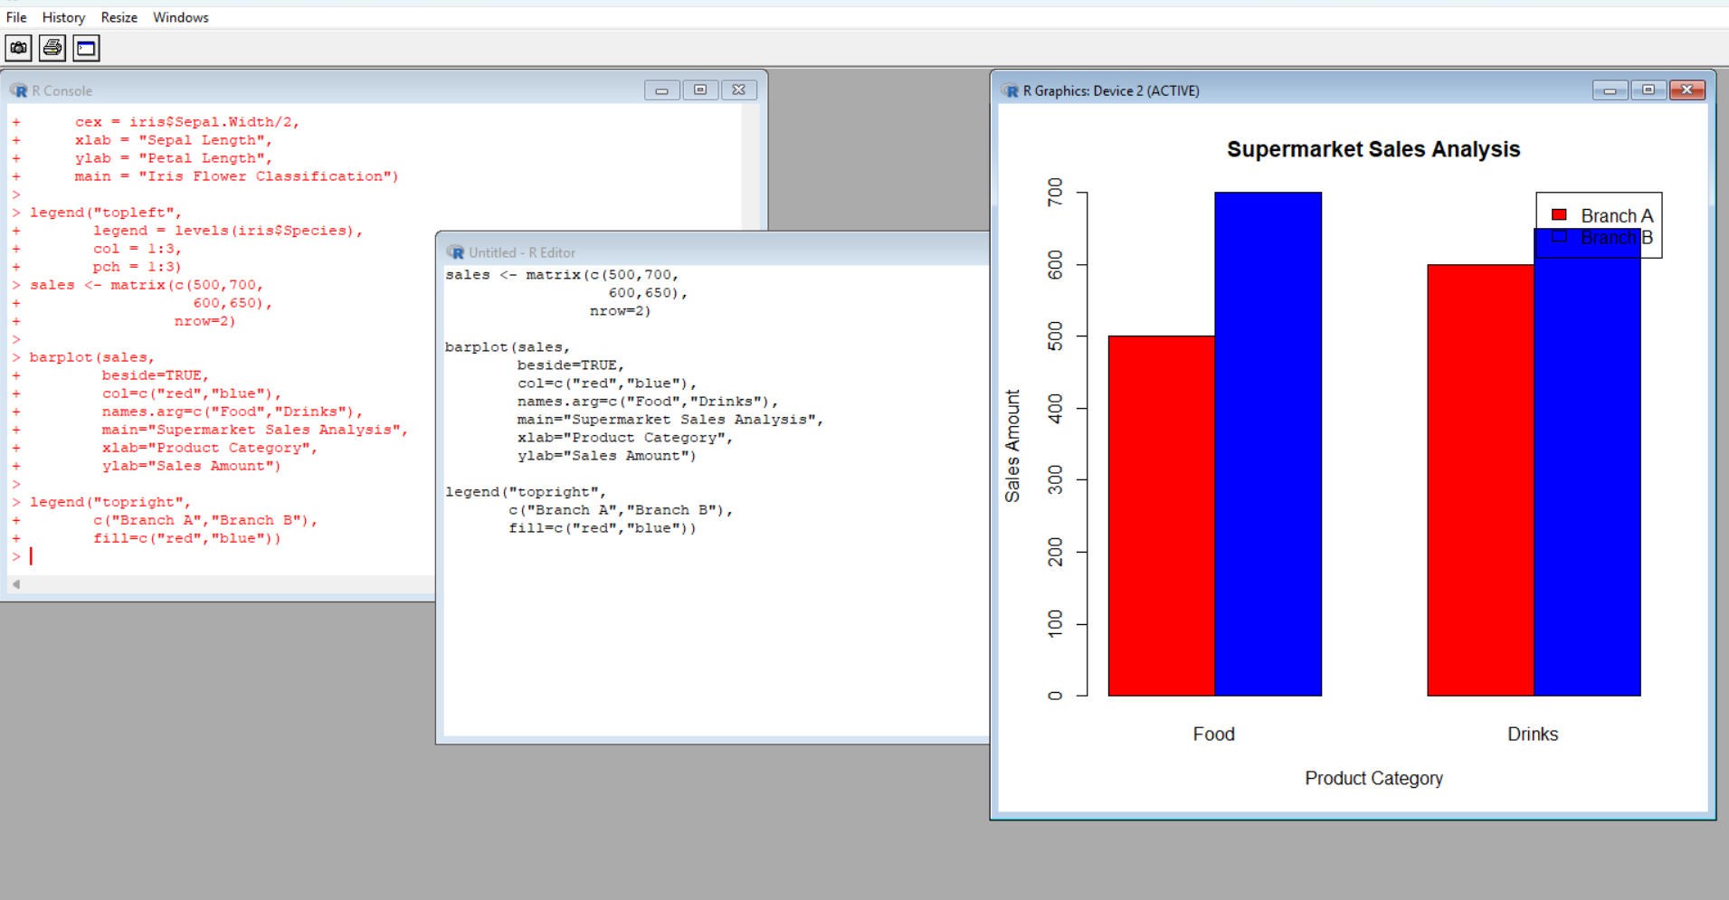

6: Employee Salary Distribution

sales <- matrix(c(500,600,700,650),
nrow=2, byrow=TRUE)

barplot(sales,
beside=TRUE,
col=c("red","blue"),
names.arg=c("Food","Drinks"),
main="Supermarket Sales Analysis",
xlab="Product Category",
ylab="Sales Amount")
legend("topright",
legend=c("Branch A","Branch B"),
fill=c("red","blue"))
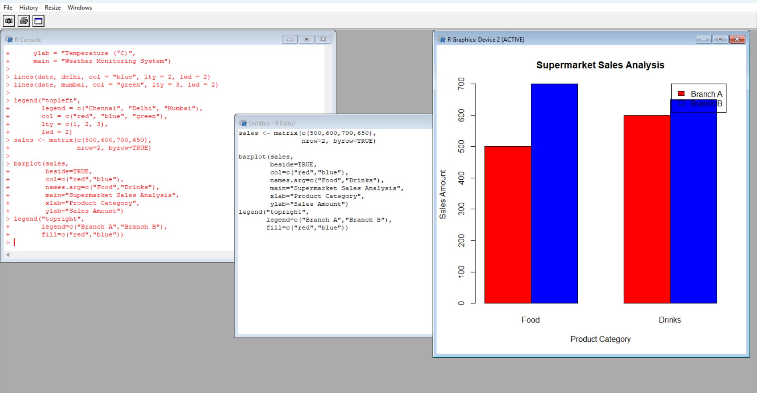

7: Smartphone Market Comparison

ram <- c(4, 6, 8, 12)
price <- c(15000, 20000, 30000, 40000)

plot(ram, price,
pch = c(15,16,17,18),
cex = c(1,2,3,4),
col = c("red","blue","green","orange"),
xlab = "RAM",
ylab = "Price",
main = "Smartphone Market Comparison")
legend("topleft",
legend = c("Samsung","Vivo","Oppo","Apple"),
pch = c(15,16,17,18),
col = c("red","blue","green","orange"))
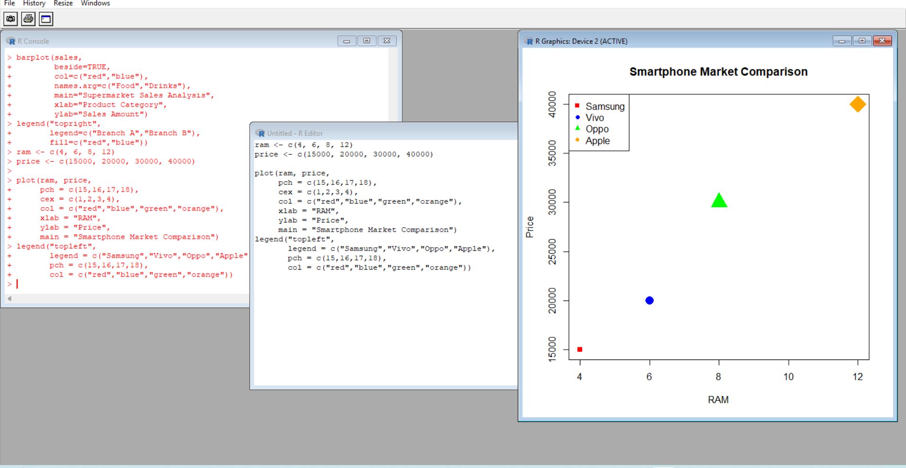

8: Online Movie Rating Analysis

ratings <- matrix(c(
4.5, 4.2,
3.8, 4.0,
4.1, 4.3,
4.8, 4.6
), nrow = 4, byrow = TRUE)

rownames(ratings) <- c("Action", "Comedy", "Drama", "Sci-Fi")
colnames(ratings) <- c("2023", "2024")

heatmap(ratings,
Rowv = NA,
Colv = NA,
scale = "none",
col = heat.colors(10),
main = "Online Movie Rating Analysis")

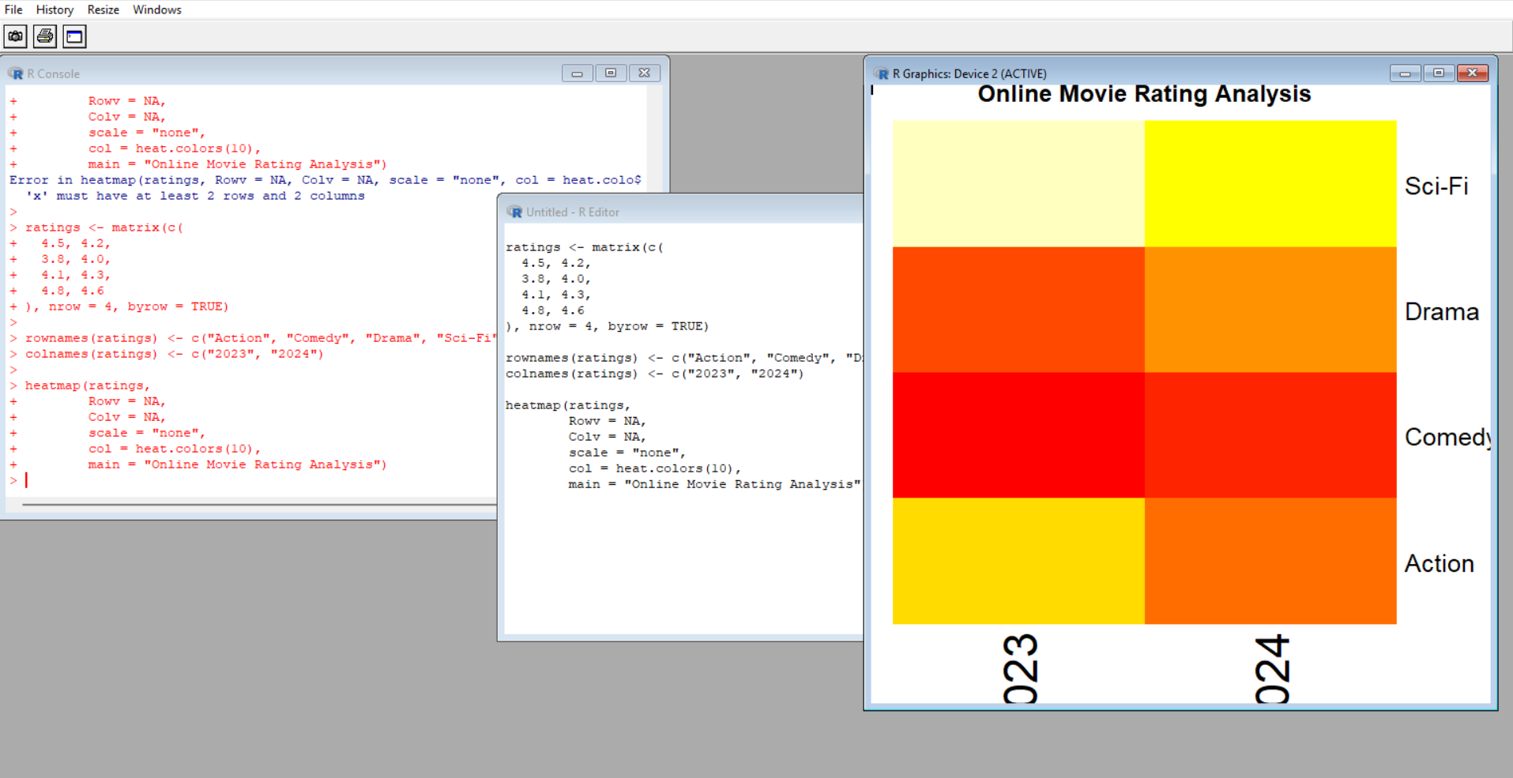
9: COVID-19 State-wise Analysis

cases <- matrix(c(1200, 800,
500, 1500),
nrow = 2)
image(cases,
col = heat.colors(10),
main = "COVID-19 State-wise Analysis",
axes = FALSE)

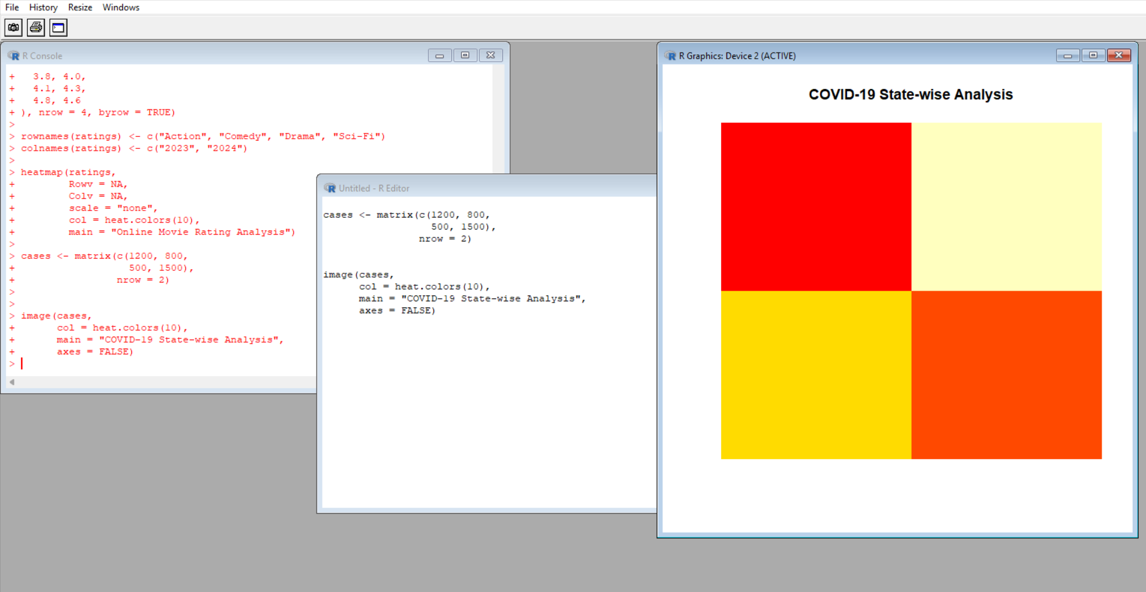

10: Iris Flower Classification

plot(iris$Sepal.Length,
iris$Petal.Length,
col = as.numeric(iris$Species),
pch = as.numeric(iris$Species),
cex = iris$Sepal.Width/2,
xlab = "Sepal Length",
ylab = "Petal Length",
main = "Iris Flower Classification")

legend("topleft",
legend = levels(iris$Species),
col = 1:3,
pch = 1:3)